Make Quick Launch Wider

1. From the Page you wish to modify, click on the site actions cog, and then from the drop down choose “Edit Page”.

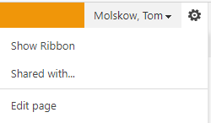

1. Once the page is in Edit Mode, scroll down to the bottom of the page and find the bottom or most right Web part Zone, and from the Web Part Zone click on the “Add a Web Part” link

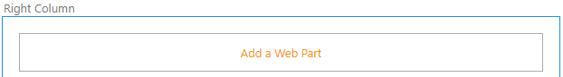

1. From the Add a Web Part interface, from the “Categories” column, choose the “Media and Content” category

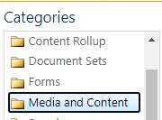

1. From the Parts column choose “Content Editor”



1. From the “About the part” column, in the drop down “Add part to” control, click on the drop down, and choose the Web Part Zone you chose in step 3 (this will place the Content Editor to that Web Part Zone)

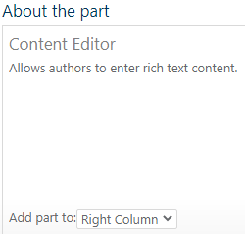

1. Now with the Content Editor Web part in place, click on the “Caret” on the right and from the drop down choose “Edit Web Part” menu item, this will open the Web Part Edit Pane

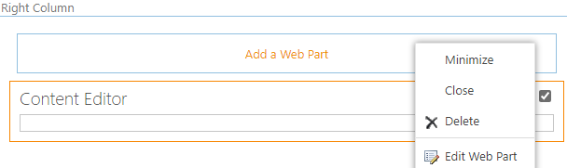

1. From the Web Part Edit Pane, in the appearance section, from the “Chrome Type” drop down choose “None”



1. From the bottom of the Web Part Edit Pane click on the “Apply” button



1. From the Content Editor Web Part, click in the middle of the web part where it says “Click here to add content”

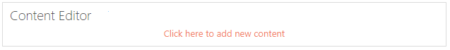

1. From the Ribbon, on the right, choose “Edit Source”, this will open up the Edit pane of the Content Editor Web Part



1. Copy the code from the “Menu.css” file and paste it into the Edit Pane, then click the “OK” button

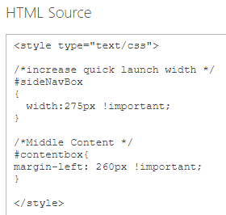

1. Back on the page, from the Ribbon click on the “Page” tab on the right, and then from the meu items below the page tab choose the “Save” button

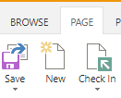

1. From the page click on the “Check it in” link (add comments if you like)



1. From the page click on the “Publish this draft” link



1. This completes the task; your Quick Launch has been updated!